2 in 1 game

A PROJECT BY:

ZAKI IMRAN

K20-O415

BCS-1D2

CONTENTS:

1. ***INTRODUCTION***

* ***ABOUT THIS PROJECT***
* ***INFORMATION***
* ***RULES***

1. ***BACKGROUND***

* ***RESEARCH***
* ***PROJECT SELECTION***

1. ***PROBLEM ANALYSIS***
2. ***METHODOLOGY***
3. ***IMPLEMENTATION***
4. ***RESULTS***

* ***FINDINGS***

1. ***CONCLUSION***

* ***SUMMARY***

**INTRODUCTION**

***ABOUT THIS PROJECT:***

This project is how integration of two games can seamlessly take place and how two totally different games with entirely different purposes can work alongside each other.

***ADDITIONAL INFORMATION:***

Other two members and partners of the project have dropped and burdened me to continue and do their work on my own as well.

***RULES:***

Rules of each game will be clearly visible in the programs…

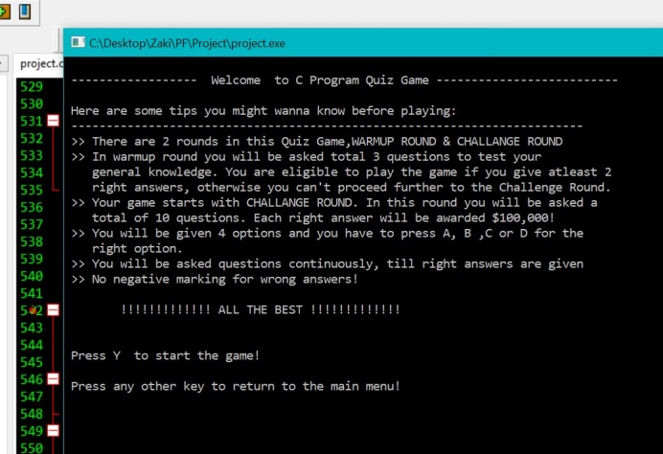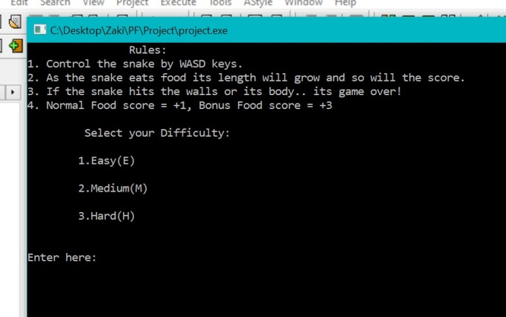

*Rules for quiz*

*Rules for snake*

**BACKGROUND**

***RESEARCH***

We had to refer to various sites, forums, repositories and even youtube tutorials to build and strong and efficient program free of bugs.

***PROJECT SELECTION***

This project is designed for the purpose of increasing knowledge as well as a means for relaxation and show how integration of code works. To attract users we selected a game that is popular among kids and adults likewise and even the quiz is designed to pique interests in the user.

PROBLEM ANALYSIS

While creating this project the first hurdle was the snake game itself which we had to make, using the limited resources we had and some guidance we were able to create that game. Then we had make the quiz from scratch and make it challenging for that we had to research which took quite some time.

**METHODOLOGY**

The environment used is that of dev c++ and additional resources include online blogs and yahoo answers along with github to provide better understanding and help in debugging

**IMPLEMENTATION**

By using all techniques learnt we were able to create both the games individually then combine them in a display menu for the user to select their desired game. Modules, loops, procedures, case statements were among some of the used techniques.

**RESULTS**

***FINDINGS***

After countless hours of debugging and researching we made the program function efficiently, even coming across ways on how to make it better and adding more features.

**CONCLUSION**

***SUMMARY***

We were able to show how to combine games into a package. We plan to upgrade this project to an even better program in the future as we learn more techniques from our teachers…

ANY QUERIES OR QUESTIONS??

This project has also been uploaded on github

https://github.com/zakiimran99/PF-project